### **Intermediate**

#### **Botany**

There are 124 species in the Coffea genus  
Approximately 55 species are indigenous to Madagascar

C. canephora and C. eugenioides are the presumed parents of C. arabica  
C. liberica accounts for up to 1-2% of total global production

#### **Varieties**

Source: World Coffee Research Variety Catalog

Spread throughout the globe between 1600 and 1850

Ethiopia -> Yemen -> India -> Indonesia -> Central and South America

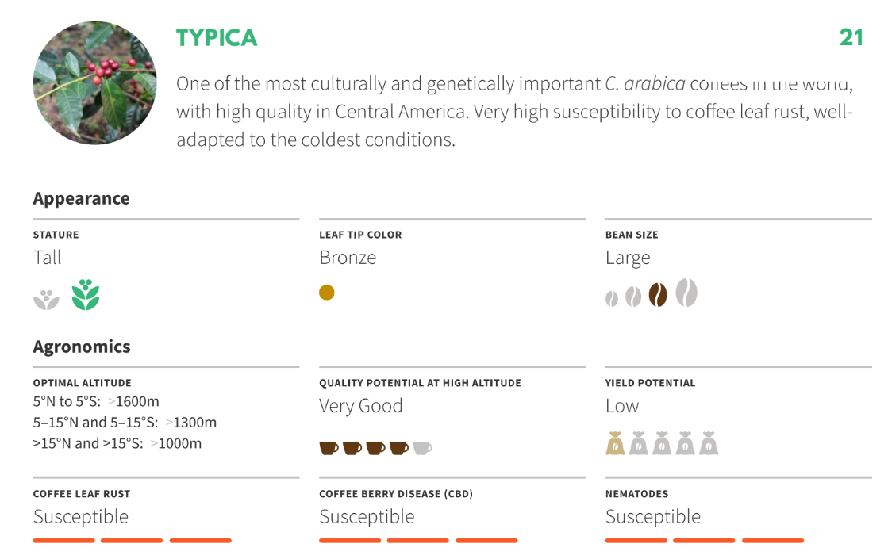

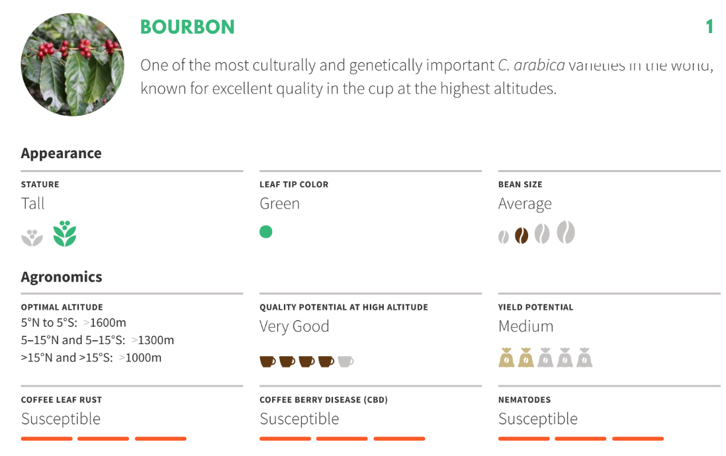Varieties like Caturra are mutations of Bourbon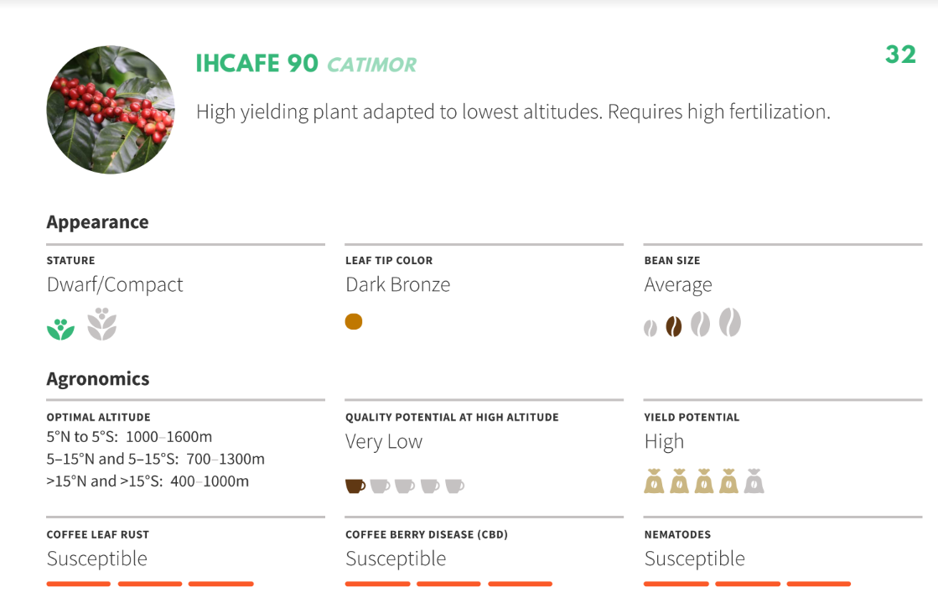

Catimor comes from Caturra (Arabica) and Hybrido de Timor (Arabica/Robusta hybrid)

Many Arabica cultivars had origins as Catimor varieties.

Cultivars have developed over the last 500 years as a result of selective breeding.  
A hybrid plant has both Arabica and Robusta genes, but is categorized as Arabica.  
“Introgression” of genes is a long process.

C. canephora was not described until 1890

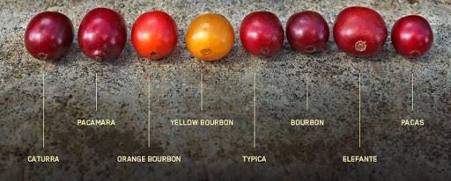

Arabica self-pollinates while Robusta needs to be cross-pollinated.

Plant breeding mainly focuses on disease resistance and increased yield.

Spontaneous mutation can cause different ripe fruit colors.  
Shape and size characteristics vary, usually ranges from screen 14 through 20

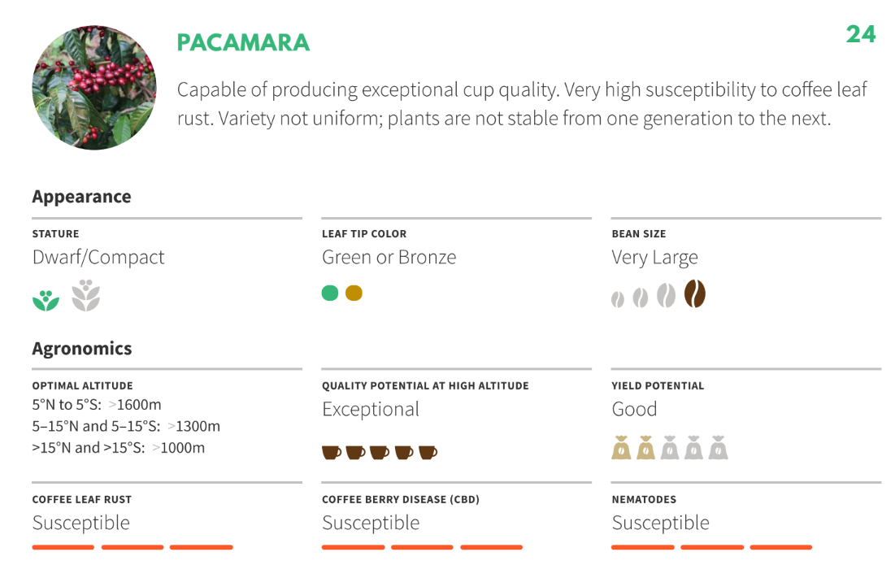

#### **Growing Conditions**

Rainfall

* 60 to 80 inches per year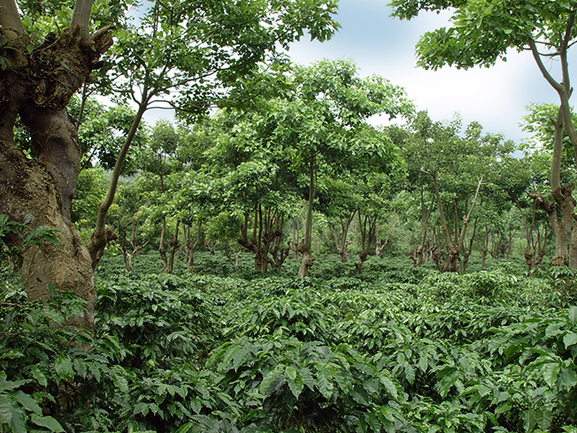

Soil

* pH varies from acidic to neutral (~4-7)

Temperature Range

* 64° to 72° F (18° to 22° C)
* Sensitive to cold / frost

Shade

* Cools temperature
* Helps with soil moisture and water control
* Blocks wind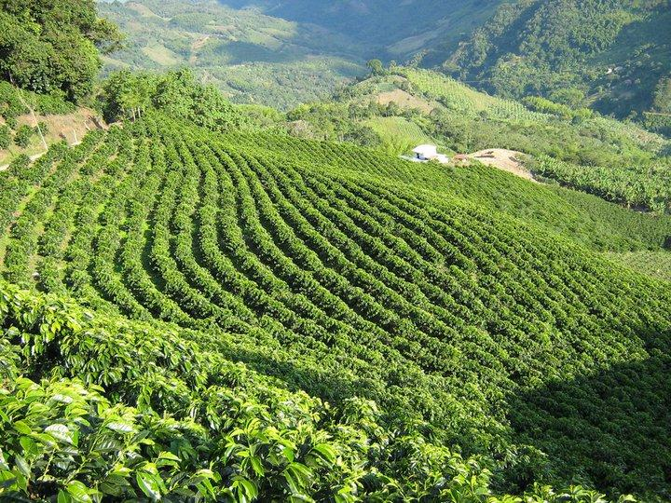

Sun

* Requires more nutrients/fertilizer
* Ripens more evenly
* Higher yield
* Less coffee leaf rust due to drier environment

Altitude

* Arabica 1000 to 2000+ masl
* Robusta 0 to 1000 masl
* Coffee grown at higher altitude is denser, harder, and has a narrower center cut. Also tends to benefit acidity and flavor characteristics (assuming careful processing)

Latitude

* Between the tropics of Cancer and Capricorn
* ~ 23° North and South of equator

Typically a one crop plant, but rains will lead to two crop cycles (main and fly)

Biennial in nature, has a large crop year followed by a vegetative year

#### **World Production**

ICO.org publishes reports and historical data *in millions of 60 Kg bags*

Statistics will vary every year due to changes in consumption, prices, weather (drought/frost), natural disasters, plant diseases

2017/18 crop year totaled 159,663,000 bags (60 kg)

Top Producers

|  |  |
| --- | --- |
| Arabica | Robusta |
| Brazil | Vietnam |
| Colombia | Brazil |
| Honduras | Indonesia |

Ethiopia produces the most Arabica in Africa

Nordic countries have the highest consumption per capita

Asia and the Middle East are the fastest growing regions in terms of green coffee importing

#### **Farming**

70% of producers are smallholders  
Generally defined as producers with less than 10 hectares in most regions (or < 20 hectares in Brazil)

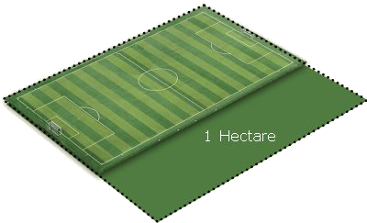

|  |
| --- |
| Average Farm Size  (largest to smallest) |
| Brazil |
| Colombia |
| India |
| Ethiopia |

Larger farms usually hire seasonal laborers to help with harvesting

Finca, Fazenda, Estate, Domaine

Cooperative, Beneficio

#### **Plant Management**

Fertilizers and pesticides are used to maintain productivity  
Pruning ensures productivity and quality

* Divert more of the plant’s resources to the growth of cherries
* Limit height of plant for easier harvesting
* Remove old wood that produces less flowers

If left unpruned the plant will spend more resources on feeding branches instead of cherries.

Inputs are dictated by:

* Economic cost
* Certification
* Local availability
* Technical knowledge
* Support from the government or cooperatives

#### **Flower to Fruit**

The cycle predominantly determines the timing and availability of fresh coffees from each country

Depends on variety, weather, soil nutrients and inputs, maturity of the tree

Rain is the main factor governing the flowering of coffee in Brazil

Crop cycles will begin later at higher altitudes

#### **Ripening**

Arabica

* 6-8 months

Robusta

* 9-11 months

Liberica

* 1+ year

#### **Seasonality**

Every origin is different  
Typically starts at lower altitudes, meaning lower grown coffee ships first  
The best coffees from each region are available at different times of the year  
Usually in the drier winter seasons, depending on the hemisphere

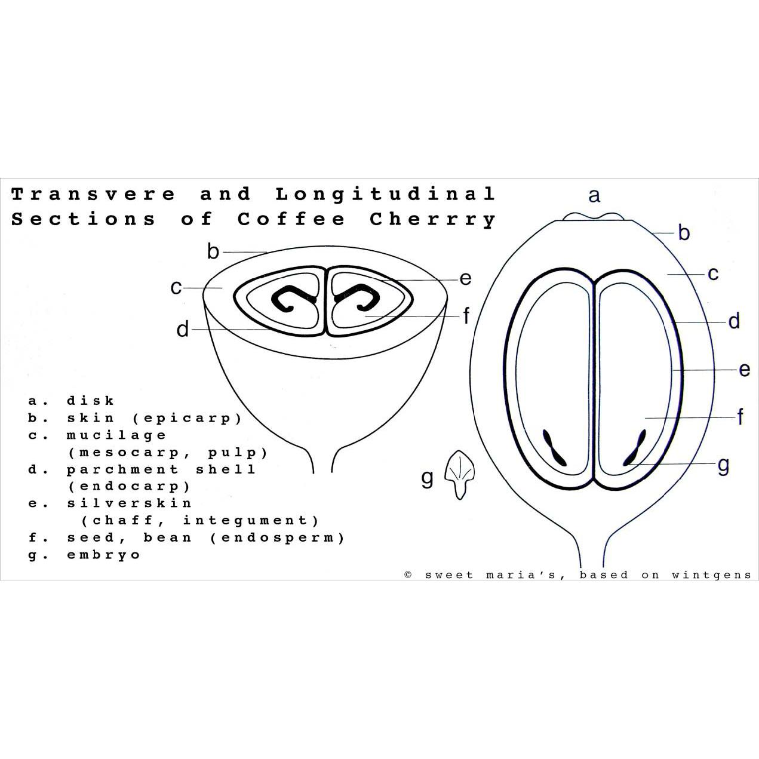

**Weight Terms**  
Only 18 - 20% coffee weight is the final green coffee we roast

|  |  |
| --- | --- |
| **State of Coffee** | **Kg per Kg of Green Coffee** |
| Fresh cherry | 5.56 |
| Dry cherry | 2.25 |
| Freshly pulped coffee | 3.39 |
| Washed and drained parchment | 2.31 |
| Dry parchment | 1.25 |
| Green coffee | 1.00 |
| Roasted coffee | 0.85 |

#### **Picking**

Review: strip, selective, mechanical

*Fully ripe coffee has a moisture content of 60 – 65%*  
Over ripe can have as little as 30 – 35%

Under ripe coffee can result in quakers and impart astringency in the cup

Coffee is stripped at the end of the season to prevent disease

#### **Washed Process**

Flotation tank to sort/remove defective coffee, followed by pulping  
Channelling separates beans by density, undesirable cherries float

*Fermentation removes the mucilage, alternatively there is mechanical processing*

Concrete, tile, stainless steel tanks

Monitor time, temperature, pH, brix  
Newer term: “parchment dried”

*Colombia produces the most washed Arabica*

#### **Natural Process**

This is the most common process in the world

Picking -> Sorting -> Drying  
Winnowing is tossing and removing debris  
More risk associated with unseen defects

Newer term: “fruit dried”

Brazil produces the most natural Arabica

#### **Semi-Washed Process**

Pulped and mucilage is left on the seeds prior to drying

Ecopulpers use little to no water   
Removing different amounts of mucilage changes cup characteristics  
Black, red, yellow, white honey

Newer term: “mucilage dried’

#### **Wet-Hulled Process**

Typically associated with Sumatra  
Traditional name is Giling Basah  
Parchment is removed at 25-35% moisture  
Newer term: “seed dried”

#### **Monsoon Malabar**

Specific to India  
Coffee is left out during heavy rains  
Leads to large white-ish yellow beans

#### **Drying**

*For washed or semi-washed, a depth of 2-4 cm is ideal for parchment on raised beds*  
For naturals, depth is 4 to 6 cm of whole cherry  
If above these levels, the risk for mold and earthy flavors increases

Musty and ferment flavors can result from inconsistent and poor drying

Drying must be on impervious material to prevent the risk of Ochratoxin A (OTA)  
Raking is necessary to obtain defect free coffee  
Coffee may be covered in case of rain or excessive humidity

Maximum temperature in mechanical dryers for optimum quality is 104° F  
*Target moisture content is 12%*

#### **Ochratoxin A**

A mycotoxin found in green coffee produced by species of fungi  
Occurs in coffee as a result of poor hygiene and quality control in post-harvest processing, most likely during drying  
Chris Kornman at Royal has written great articles on the topic

#### **Resting**

Coffee rests in parchment for minimum of 30 days and sometimes up to 120 days  
*Allows moisture level to stabilize  
Results in a less astringent cup*

Held in silos, supersacks or grainpro bags

#### **Dry Mill**

Remove parchment

*Gravity separators (Oliver tables) sort by density*

*Defects linked to lower density include insect damage and black beans*

Screens sort by size

Hand sorting and optical sorting

#### **Grading**

Different countries have different systems  
AA, AB, AB/C, C

Supremo - Scr 17 percentage below must be 5% or less (some accept up to 10%)

Excelso - Scr 15

UGQ - Scr 14

Scr 17/18, Scr 14-16, Scr 15+

|  |
| --- |
| Grades by Altitude in Central America (highest to lowest) |
| Strictly Hard Bean (SHB) / Strictly High Grown (SHG) |
| Hard Bean (HB) / High Grown (HG) |
| Extra Prime Washed (XPW) |
| Prime Washed (PW) |

European Prep (EP)

Gr 1 through 5

Undergrade or segunda

FAQ

X, Y

TP, DP

#### **Defects**

Found in SCA Green Grading Handbook

Primary and Secondary categories

Damage can occur in the field, process, or storage

*Sample weight is 350g*

#### **Quakers**

Appear much lighter than the rest of the roast  
If there are many quakers, the roast is “motley” or not uniform  
Tastes like peanut skin, unpleasant or drying nutty flavor

#### **SPOT**

Buy from a trader/importer  
XWH or FOT, already in a US warehouse  
Can be delivered immediately  
Usually SAS (Subject to Approval of Sample)

#### **Futures**

“C” market level +/- differential  
Premium or discount to reflect value of a specific quality

Contango or forwardation position is when the forward price of a futures contract is higher than the spot price...generally the case in coffee

An inversion or backwardation is when the forward price of a futures contract is lower than the spot

#### **Arbitrage**

*The price difference between the New York and London markets when compared in the same unit of weight*  
Arabica is usc/lb  
Robusta is USD/MT

One metric tonne equals roughly 2204 lb

#### **Hedging**

Financial tool for risk management  
“trading operation that enables management of the risks posed by unforeseen price movements”

#### **Contracts**

Two main organizations who set standards for contracts

* Green Coffee Association
* European Coffee Federation

Outlines the following:

* quantity in net weight
* quality
* price (to be fixed or outright)
* payment terms
* delivery period
* location
* other terms and conditions

Signed by buyer and seller, disputes are settled through arbitration

#### **Shipping**

FOB

CIF  
FOT / FCA  
XWH  
*Bill of Lading (like a title of ownership)*  
Weight Note

Phytosanitary certificate (not always required)

Certificate of Origin

Forwarding agents…

* Confirm accuracy of the ICO marks
* Offload coffee containers from the ship
* Draw representative samples of green coffee
* Weigh coffee at arrival
* Store coffee in a warehouse

Importers are responsible for checking the quality attributes of a green coffee when it arrives at the port of destination.

#### **Bags**

|  |  |
| --- | --- |
| **Region** | **Weight** |
| Mexico & Central America | 69 Kg |
| Brazil | 59 or 60 Kg |
| Colombia | 70 Kg |
| Africa & Asia | 60 Kg |

*Sometimes India and others in 50Kg bags*

*Microlots sometimes 30 Kg or 15 Kg v*acuum-sealed + boxed

Burlap / Jute / Hessian  
Grainpro / Ecotact

Super sacks or container liners

#### **ICO Marks**

11 digits

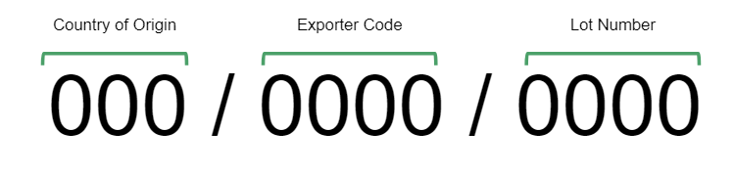

A coffee shipped without marks means the exporting country is not a member of the ICO

#### **Moisture**

Condensation can build up during shipment   
Containers must be sealed properly  
Containers can be lined with hygroscopic desiccants such as kraft paper, silica gel or clay to absorb moisture

#### **Storage**

Humidity range 50-70%

Temperature range 50-70°F

Controlled humidity and stable temperature at or below 68°F will have the greatest impact on preserving quality

#### **Quality**

Roasters and importers have a “time bar” for placing quality claims  
Must evaluate appearance and cup of arrival sample ASAP  
Notify the shipper immediately if there is an issue  
Usually within 10 days of landing

#### **Certifications**

Rainforest Alliance

* Recently merged with UTZ
* *biodiversity, conservation and community development*
* *workers’ rights and productive agricultural practices*
* *comprehensive sustainable farm management, including wastewater recycling*

Fair Trade

* Two organizations: FT USA and FLO
* Guarantees a minimum price
* community development and environmental stewardship

Organic

* ecological processes
* biodiversity and cycles adapted to local conditions
* avoid agrochemical inputs

#### **Decaffeination**

MC / DCM

* *Methylene chloride / Dichloromethane*
* Has shortest treatment time

EA

* *Ethyl acetate*
* Solvent can be derived from fermented sugar cane

Organic

* *CO2*
* *Water*

#### **Lab Requirements**

Non-reflective, neutral counter  
Lighting for green grading  
Red light

Black light - detect ferment and mold

#### **Sizing Screens**

Used to determine if a sample meets the contract specification  
Generally up to 10% under is accepted

#### **Moisture Meters**

Portable, for use in the field or limited space

Larger models have more functions, can also measure density

Different machines have different tolerances and need to be calibrated

Samples should be measured at room temperature

#### **Water Activity**

Defined as a measurement of free water in green coffee to guarantee safe storage.

Measured from 0.00 to 1.00 aW

“Should be” 0.50 to 0.60

The SCA standard is up to 0.70 due to the risk of fungi development